**Subject: SESE: Science/ Geography: Senior Classes.**

**Introduction to Weather Recording.**

**Learning Outcomes:**

* to introduce pupils to weather features and weather recording.
* To enable pupils to be active agents in the exploration of the weather
* To enable pupils to gain an understanding of various weather features such as precipitation, wind speed and temperature.
* To help students to practice a range of scientific skills of recording weather features.
* to develop open critical and responsible attitudes to the environment.

**Links with other lessons**- Oral language, Mathematics, Digital Technology

**Materials/ Resources:** Weather station, rain gauge, thermometer anemometer, stop watch.

**What is wind ?** The wind can be described as the movement of air. Warm air rises and colder air moves down to take its place. It is a force which can be felt but not seen. We can see the effects of wind.

Discuss the advantages and disadvantages of the wind.

**How do we measure wind speed?**

We use an instrument called an anemometer to measure wind speed.

Look at different pictures of anemometers,

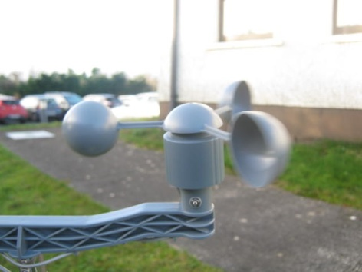

The speed at which the cups rotate is proportional to the speed of the wind. So, by counting the number of turns over a period of a minute with the help of a stop watch.

Place the anemometer outside to see if the wind will spin it around. Using the watch, count the number of times the marked cup spins around in one minute. Repeat this everyday for a month. Record the data on the notepad. Record on Excel.

Use Digital Technology to record wind speed. Show the results on a graph.

Choose one month in winter and one in summer to show differences. After a month of recording, draw a graph to represent the data. Plot the days along the horizontal axis and the wind speeds (turns per minute) along the vertical axis.

**Analysing results:** Ask the following questions: Has the wind speed changed over the month? Are there any differences between winter and summer months? What was the windiest day? What was the calmest day? Calculate the average (mean) wind speed for the month by adding up the wind speed recorded on each day and dividing your result by the total number of days in the month. Repeat the experiment in different locations to record and compare the wind speed. Try to explain why there might be variations.

**The Beaufort Scale**

Wind can be measured by the Beaufort scale. The scale was devised by Sir Francis Beaufort from Navan, County Meath. It is a way of estimating the wind strength according to the appearance of the sea or land. It was created more than 200 years ago but it is still used across the world today. Wind force 0 is calm. Wind force 12 is a hurricane.

|  |  |
| --- | --- |
| Force 1 | Calm |
| Force 2 | Light Air |
| Force 3 | Light Breeze |
| Force 4 | Gentle Breeze |
| Force 5 | Moderate Breeze |
| Force 6 | Fresh Breeze |
| Force 7 | Strong Breeze |
| Force 8 | Gale |
| Force 9 | Strong Gale |
| Force 10 | Violent Gale |
| Force11 | Storm |
| Force 12 | Hurricane |

**Further Study: The Trade Winds , The Jet stream.**

**Where is the windiest place in the world?** The windiest place in the world is the George V Coast in Antarctica, where winds of 320 km/hr have been recorded.

**What are the prevailing winds in Ireland?** The prevailing wind in Ireland comes from the southwest. Wind in Ireland is most likely to come from this direction. Use a wind rose to record wind. Design a wind rose and keep track of wind direction using a weather vane or a weather station.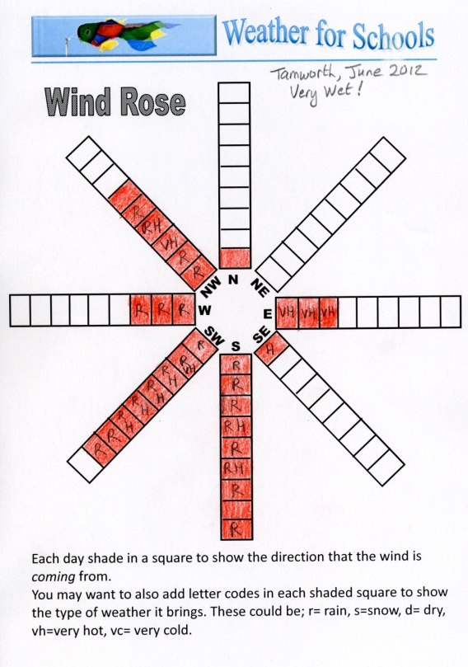

**A weather vane** is used to indicate the wind direction. They are often seen on the steeples of churches. Can you draw a picture of a weather vane?

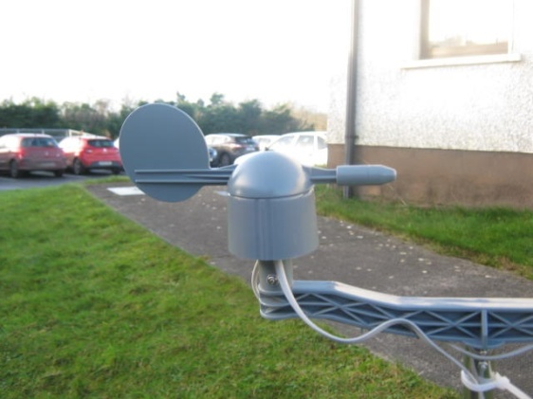

**Temperature**

**What is Temperature?** : It is the degree of heat or cold. It is measured by a thermometer. It is measured in degrees Celsius or degrees Fahrenheit. The Celsius scale is most commonly used in Ireland. It is also known as the ‘centigrade’ scale. It is divided into 100 parts.

There are many different **types of thermometers.** A mercury thermometer is most commonly used in weather readings. **How does a thermometer work** ? A glass column contains mercury. Mercury expands when it is heated and contracts as it cools. As the temperature rises, so too does the mercury. We read the temperature from the scale marked on the outside of the column.

Link with mathematics and negative numbers.

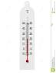

**When do we use a Thermometer?**

In the fridge. It is important to store food at a low temperature in order to keep it fresh.

In the oven. In order to cook food, the oven must be set at a high temperature.

Ireland’s temperature. The average annual temperature for Ireland is 9°C. Ireland does not suffer from the extremes of temperature experienced by many other countries at similar latitude. What is room temperature? We often hear the phrase ‘room temperature’. Room temperature is an indoor temperature from 15 to 25°C (59 to 77°F). This temperature is suitable for human occupancy.

**Precipitation**

The term refers to a mixture of rain, sleet, hail and snow.

We can measure rainfall by means of a rain guage. Rain gauges come in many styles. A rain gauge consists of a funnel, a collecting jar and a measuring tool in millilitres. The collecting jar can be sunken into the ground .The rain falls into the funnel and collects in the jar. The gauge has a measuring cylinder which measures the amount of water collected in the glass jar in millimetres.

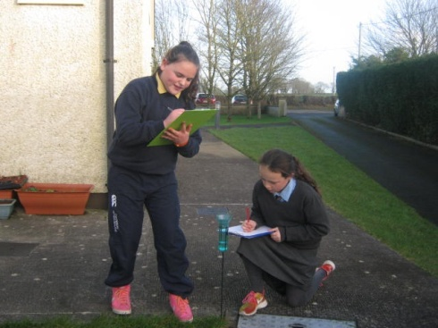

**Other Forms of Precipitation include:**

Snow crystals form when water droplets in clouds become very cold. The snow crystals fall from the cloud forming snowflakes. The air below must be freezing or the snowflake will melt and turn to rain. Sleet is a mixture of snow and rain. It is not light and fluffy like a snowflake.

Hail is hard frozen rain. It is usually the size of a pea, but sometimes grows as large as a golf ball! Hail can fall from the sky at any time of the year, not just during winter.

**The Water Cycle:** Explain the cycle of Evaporation, Condensation, Precipitation and Runoff. Cloud Types. When the sun heats water in rivers, seas or lakes it turns into water vapour. The water vapour rises into the sky and forms clouds. There are four main names: cumulus, stratus and nimbus and cirrus.

**Humidity:**

The air around us has a certain weight. The weight is called atmospheric pressure. Warm air is light and it moves upwards and creates low atmospheric pressure. Cold air is heavy. It presses down on the earth and creates high pressure. Humidity is measured by a barometer.