**Project Day as part of the ERASMUS + program: "STEM for all seasons" on the subject of weather**

At the elementary school Aystetten

Parents’ booth:

Exploring how weather influences the growth of vegetables while cooking a delicious soup with vegetables the pupils brought from home.

**Today, we would like to take a closer look at the influence of weather on our food using local vegetables. Everyone has brought a few vegetables, so that we can prepare a delicious vegetable soup which can be eaten by the children at the end of the project day.**

* **Who of you has a garden at home and even grows some vegetables and fruit?**
* **Which local vegetables do you know that are normally harvested in autumn?**

Answers:

* carrot
* potato
* parsnips
* celery
* radish
* sweet potato
* turnip
* salsify
* beetroot
* leek
* pumpkin
* cabbage
* brussels sprouts
* broccoli
* cauliflower
* onion

and so on…

* **The vegetables that can be harvested in the autumn also have the advantage of easy storage and thus, make a good supply for the winter. Previously, autumn vegetables were stored in the cool cellar. The vegetables remained stable in the cellar because of the cool temperatures and darkness. Today, the fridge takes over this function.**
* **You certainly know what you need to grow the vegetables well, because our weather has a great influence on our plants:**

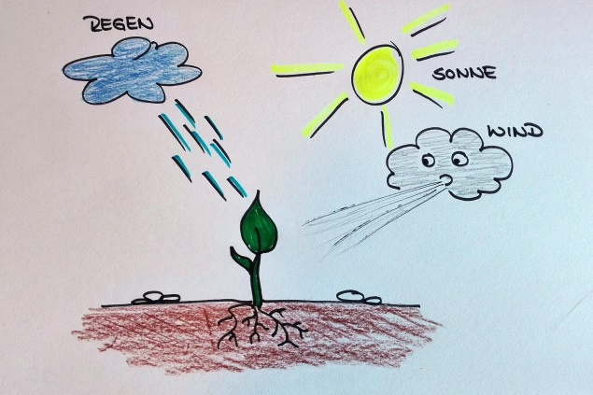

Answers:

- sun (heat for growth)

- rain (water for growth)

- wind (for the stability of plant parts)

* **What weather phenomena are there which may affect the plants in a negative way?**

Answers:

* Temperatures too high and too long

🡪 Heat periods and drying periods

Too little water means that the plants cannot grow so well, stay smaller or even dry up.

* Too much and long lasting rain

🡪 Always moist soil / waterlogging and floods

Too much moisture can promote diseases such as fungi and snail infestation. If the root area is always too wet, the plants will die too. Flooding can also destroy the whole crop when the plants are rinsed or kinked.

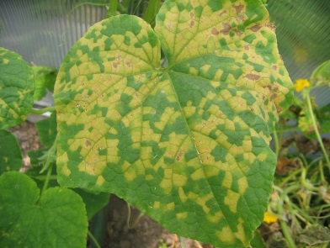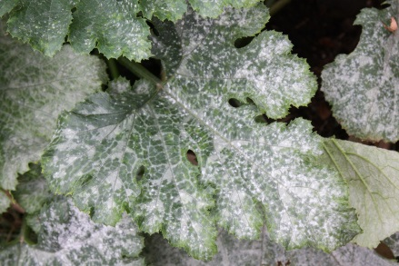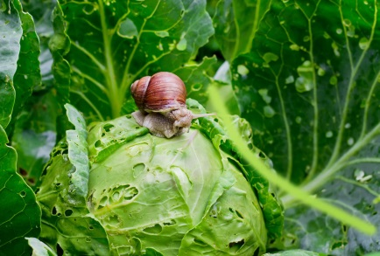

* Frost, hail, storms

**Frost** freezes the water in the plants so that no nutrients can be transported in the plant. If by late frost (for example like this year in April) the flowers can freeze later in the year and therefore, no fruit grow on the tree. The growth of the plants also begins later in the year and the harvest period shifts accordingly.

Autumn and winter vegetables, on the other hand, tolerate some frost (rosary, field salad, etc.)

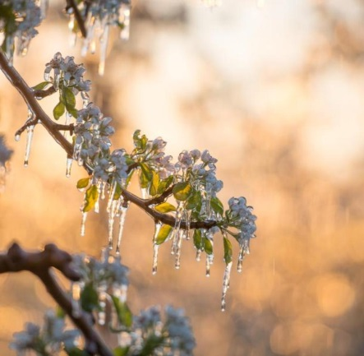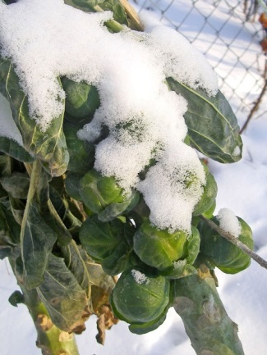

**Hail** can damage the leaves and fruits or the whole plant, which cannot grow any longer.

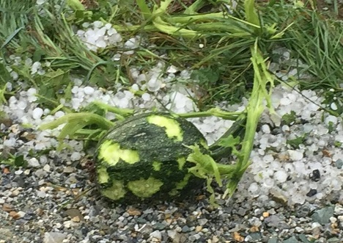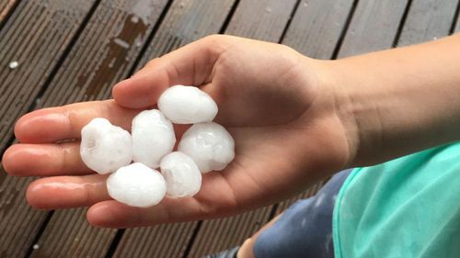

**Storms and too much wind** may also damage the plants, rip the fruits too early from the trees or damage the fruits so that they are consumed earlier than normal and cannot be stored for the winter. Wind can also dry up or even remove the soil (this is called “erosion”) and thus, removes nutrients.

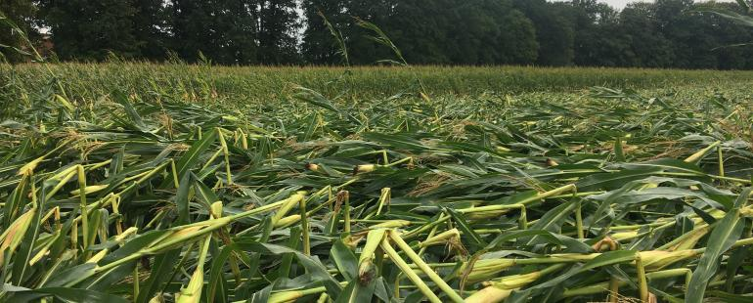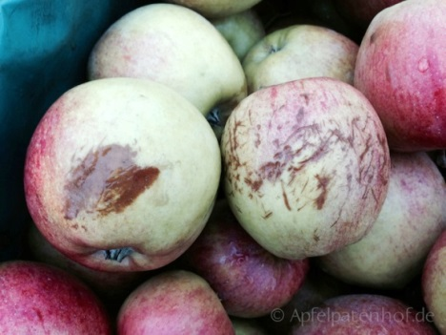

* 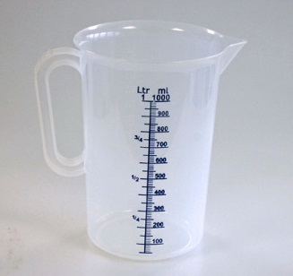**Now there is still a little quiz:**

**What do you think how much water**

* **(not just rain water) is needed**
* To make a bag of potato chips?

(925 liters of water)

* 1 kg of carrots?

(130 liters of water)