**Build your own weather station.**

**Subject areas:**

Science, technology, maths, engineering.

**Class:**

Senior classes - primary school.

**Objectives:**

* Enable the students to design and construct a rain gauge, barometer, anemometer, psychrometer, and wind vane using the materials of their choice.
* Enable the children to select a suitable location for theiur weather instruments
* Using Microsoft word construct a table to record weather data under the following headings
  + rainfall
  + wind direction
  + wind speed
  + air pressure
  + temperature
* Enable the children to record daily weather data from their own weather instruments and from the school weather station
* compare and contrast the findings with those of the school weather station under the headings
  + mean
  + range
  + above and below average
* Using Excel encourage the children to record their findings using suitable graphs
  + Bar line graphs
  + Trend graphs
  + Pie charts
* Provide the pupils with an opportunity to present and display their findings

**Building a Rain Gauge:**

**Background:**   
  
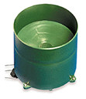Rain gauges measure rainfall over short or long periods of time. Short-term gauges are checked after each rainfall. They can simply be open jars left outside to collect rain and measured each day. A more complex rain gauge has oil in it to keep rain water from evaporating over long periods of time.

**Materials:**

* 2 two-litre bottles (tops removed)
* permanent marker
* ruler
* duct tape
* vegetable oil

**Procedure**:

1. Carefully cut a two-litre bottle in half to make a funnel.
2. Place the cut bottle on the uncut bottle so that spouts are touching and in line.
3. Tightly tape the bottle spouts together.
4. Mark the rain gauge up the side in 5millilitres graduations with the permanent marker.
5. Pour in enough vegetable oil to cover the bottom of the rain gauge in a thin layer.
6. Place the rain gauge outside, preferably in a shady, but not covered, spot.
7. Decide on a time period to wait before collecting data.
8. Keep a record of rainfall totals for each day

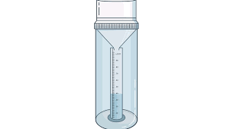

**Building a Wind Vane:**

**Background:**   
  
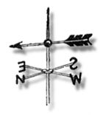A wind vane is a flat piece of metal or wood on a swivel that catches the wind and points toward and away from the wind. It is usually shaped like a farm animal such as a horse or a rooster. It usually has an arrow to point in the direction the wind is blowing. However, wind is described in terms of where it is blowing from. For example, a west wind blows east.

**Materials:**

1. Round plastic drinking cup with lid
2. Pebbles or sand
3. Pencil
4. Drinking straw
5. Straight pin
6. Card
7. Permanent marker
8. Compass

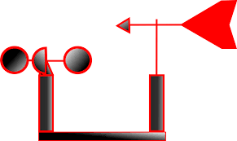

**Instructions:**

1. Put the lid on the plastic container, and turn the container upside down. Trace around the lid, and then make another circle around the outer edge, at least 4 cm wider than the first one.
2. Divide the lid in half along its diameter, and then divide each of those halves in half. Write the words for the four parts of the compass along the outer edge of each of the four sides -North, East, South, and West.
3. Open the container. Stick a blob of modelling clay on the bottom of the container, and then fill the remainder to the top with pebbles or sand. Put the container lid
4. Glue the container, upside down, onto the cardboard compass base you just made.
5. 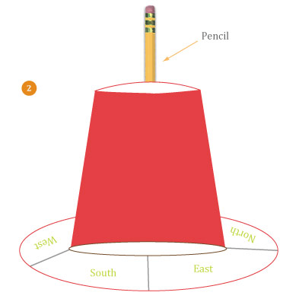Push the pencil through the centre of the plastic container. Now, cut a broad triangle and a square. Cut a slit in each end of the straw. Slide the triangle onto one end and the square onto the other. Push the pin through the centre of the straw and attach it to the top of the pencil eraser. If you flick the straw or blow on either end, it should move freely.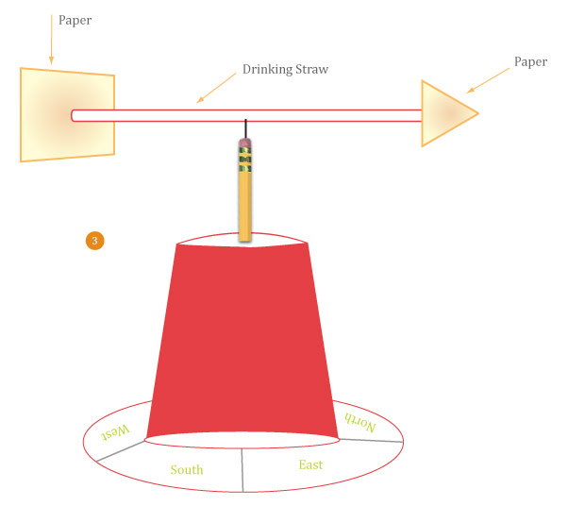
6. Take your wind vane outside to a place where the wind is not highly obstructed. Find north, south, east, and west on a real compass, and line up the wind vane accordingly. Wait for the next breeze; the arrow will point to where it’s coming from.

**Building a Psychrometer:**  
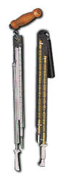

|  |  |  |  |  |  |
| --- | --- | --- | --- | --- | --- |
| **Background:**  Air is made o f gas particles that are constantly moving. Warm air particles move rapidly and cold air particles move more slowly. When air is warm, the distance between the particles is greater than when air is cold.   * Water can exist in all three states on this planet - solid liquid and gas * It will evaporate when left sitting for too long. In the gaseous form it is called water vapour. * Water vapour particles can move freely between air particles. * At higher temperatures, when air particles are farther apart and moving faster, a lot of water vapour particles can fit in between. * At lower temperatures, when air particles are closer together and moving slower, less water vapour particles can fit between the spaces, so they condense and clouds are formed. * The amount of water vapour in air is called relative humidity. * A psychrometer or a hygrometer is used to measure relative humidity.   Materials:   * Two alcohol-filled air thermometers (they must read exactly the same temperature when placed side by side out of direct sunlight) * shoelace * 2litre bottle * water * thread * relative humidity chart   **Procedure:**   1. Make a hole in the side of the bottle about 2cm from the bottom. 2. Cut about 4cm of shoestring and slip it over the bulb of one of the thermometers. Carefully tie it in place with thread. 3. Position the bulb of the shoe-stringed thermometer about 2mm over the hole. Be sure the top of the thermometer is aligned with the top of the bottle. Tape the thermometer to the bottle. Tape the other thermometer parallel to the first one and about 5cm away. 4. Push the shoelace through the hole. Put room temperature water in the bottle until it reaches just below the hole. 5. Wait 5 to 10 minutes and read both thermometers. There will be a difference in the two. Use the chart below to calculate the relative humidity chart.   weather 6.jpg  **Building a Barometer:**  **Background:**  Air exerts pressure on Earth’s surface.  **Materials:**   * Empty coffee can * balloon * rubber band * card * coffee stirrer * tape * glue   **Procedure:**   1. Tape the rim of the coffee can so the metal edge is completely hidden. Be sure the tape smoothly extends down the 5cm of the side of the can 2. Cut the filler hole off the balloon. Stretch the balloon tightly over the Barometertaped edge and secure it with a rubber band. 3. Put a drop of white glue in the centre of the stretched balloon. Put the coffee stirrer on the glue and position it so that it protrudes about 5cm over the edge of the can. 4. Tape the card on the side of the can so that it extends over the top and is close but not touching the coffee stirrer. 5. Mark the card at the tip of the stirrer. 6. Record the current barometric pressure. This will be your baseline pressure. Be sure to note the position of the mark on the card corresponding to the pressure. 7. Repeat step 6 through several cycles of weather. Be sure you have several highs and lows marked on your card.   When you become accustomed to the way your barometer works, you will have a tool with which to predict the weather.  **Assessment:**  Assessment of the lessons will be ongoing. The children will to a large extend have to assess their own work in order to progress and to determine if their weather instrument actually works.  thinking.gif   |  |  | | --- | --- | |  | | | http://school.discoveryeducation.com/lessonplans/images/spacer.gif |  | http://school.discoveryeducation.com/lessonplans/images/spacer.gif | |